School Self Evaluation
6 step process
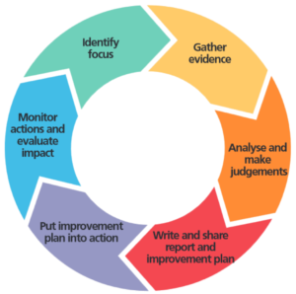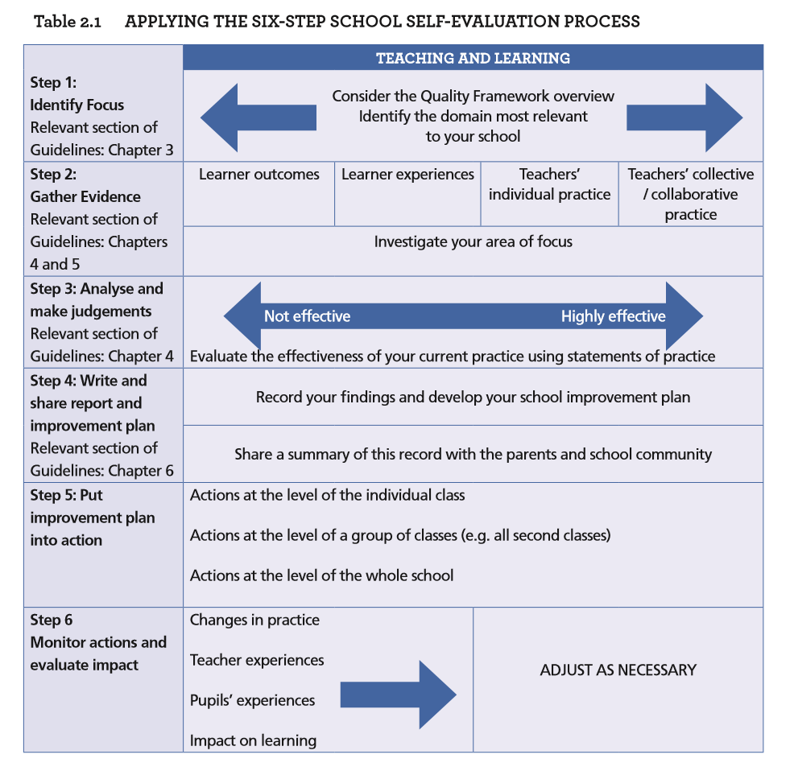

An Overview:
 | What to Use? | Done?
Step 1 – Identify Focus  Members of the school community will need to identify a curriculum area or an aspect of teaching and learning that they wish to investigate. This will be based on their sense of their own context and where they feel their school might profitably explore the potential for improvement. | Activity 1: School Audit  Activity 2: Focus area?
Step 2 – Gather Evidence  Gather evidence about what is working well and what can be improved. Typically, information should be gathered from several sources. Both quantitative and qualitative data can be gathered from several sources including teachers, pupils, parents, management, classrooms and other learning settings. | Templates/Samples: Adapted from…  http://schoolself-evaluation.ie/primary/resources/gathering-evidence/
Step 3 – Analyse and Make Judgements  Analysing the data and drawing conclusions based on the analysed data. Schools should determine, affirm and celebrate the strengths they identify in the aspects of practice being evaluated. They should also acknowledge the areas that should be prioritised for improvement. To be as objective as possible schools should judge the quality using the statements of practice in chapter 4 of the Guidelines, taking due cognisance of the school context. | Chapter 4 of SSE Guidelines.
Step 4 – Write and Share Report and Improvement Plan  Schools keep a record of their self-evaluation; plan for how they will improve the curriculum areas or aspects of teaching and learning being evaluated; and share the findings of the evaluation and the improvement plans with the school community. | Templates and further guidance here:  http://schoolself-evaluation.ie/primary/resources/reporting-sse/
Step 5 – Put Improvement Plan into Action  This is the key step in the process. It is only when the actions in the improvement plan are implemented that the work of the school can improve. All relevant school personnel should share ownership of the actions to be implemented at individual teacher, class, or whole-school level. These actions should become part of the normal teaching and learning process. | Refer back to implementation plans and report
Step 6 – Monitor Actions and Evaluate Impact  Monitor and evaluate the impact of the actions. | Refer back to implementation plans and report

Step 1. Activity 1: School Audit
Choosing a focus area:

What have we looked at so far?
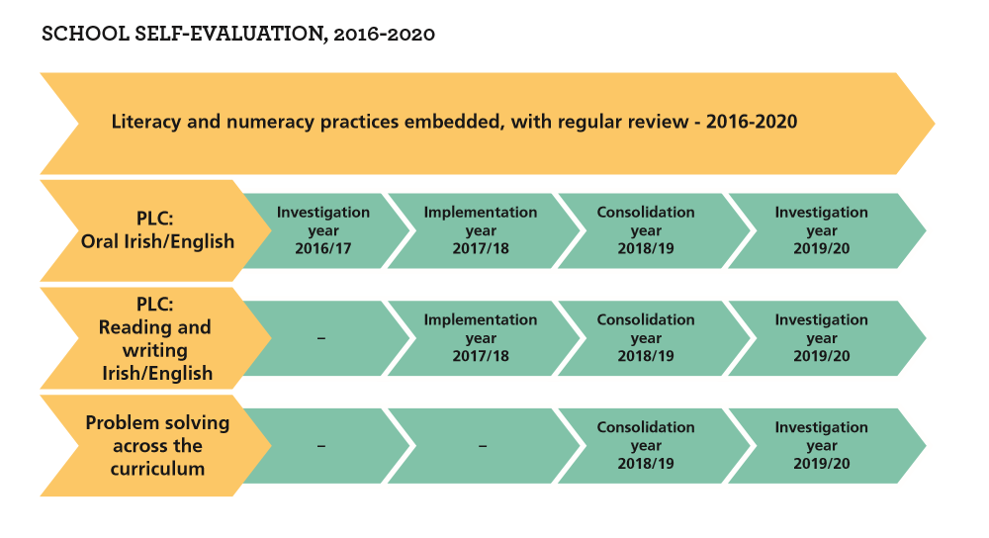
Are there any new curricular components that we need to review?
Is the cohort of students changing therefore providing guidance on an area of provision to investigate?
What do teachers feel we should look at?
What are the areas of concern for management, leadership, teachers and other staff?
What are the concerns of students and parents?
Are there any Department reviews/initiatives that warrant our focus?
What did our Whole School Evaluation recommend?
Activity 2: Focus Area – L2LPs
Teaching and Learning | Leadership and Management
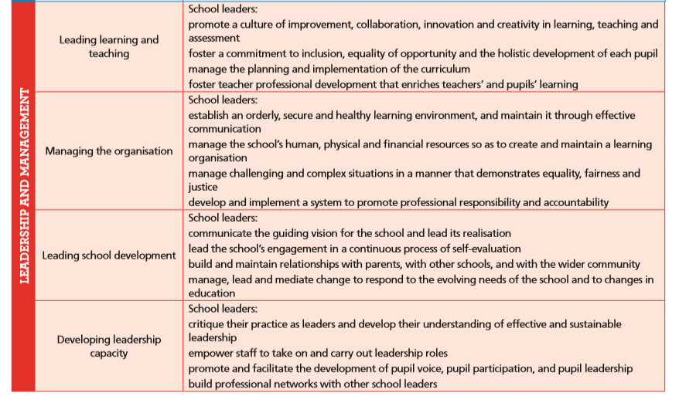
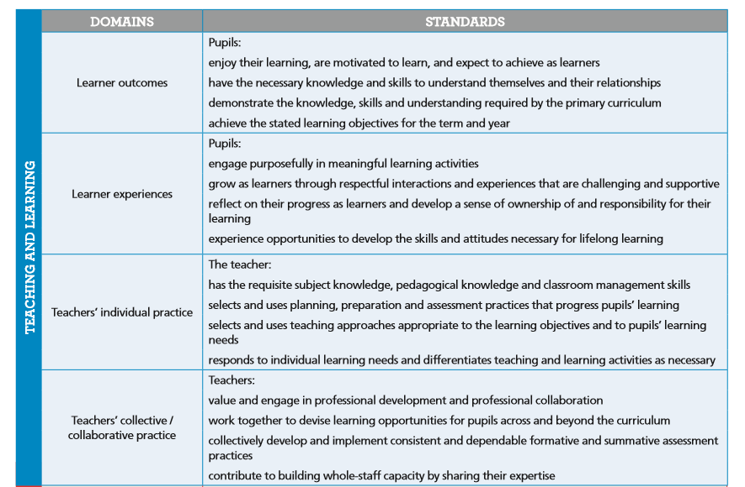

How well are we doing?
How do we know?
What are our strengths?
What are our areas for improvement?
How can we find out more?

Teaching and Learning: Learner Outcomes?
How do we know how we are doing?
How can we find out more?
What do we need to improve on?
What are our strengths?
How are we doing?
Teaching and Learning: Learner Experiences?
How do we know how we are doing?
How can we find out more?
What do we need to improve on?
What are our strengths?
How are we doing?

Teaching and Learning: Teachers Individual Practices?
How do we know how we are doing?
How can we find out more?
What do we need to improve on?
What are our strengths?
How are we doing?

Teaching and Learning: Teachers Collective/Collaborative Practices?
How do we know how we are doing?
How can we find out more?
What do we need to improve on?
What are our strengths?
How are we doing?

Leadership and Management: Leading Learning and Teaching?
How do we know how we are doing?
How can we find out more?
What do we need to improve on?
What are our strengths?
How are we doing?

Leadership and Management: Managing the Organisation?
How do we know how we are doing?
How can we find out more?
What do we need to improve on?
What are our strengths?
How are we doing?

Leadership and Management: Leading School Development?
How do we know how we are doing?
How can we find out more?
What do we need to improve on?
What are our strengths?
How are we doing?

Leadership and Management: Developing Leadership Capacity?
How do we know how we are doing?
How can we find out more?
What do we need to improve on?
What are our strengths?
How are we doing?

Step 2. Gathering Evidence

Templates found on:

http://schoolself-evaluation.ie/primary/resources/gathering-evidence/

Sample checklist for evaluation of Communication and Literacy
In accordance with their level of development and ability:
Knowledge and skills | Students listen attentively and with understanding
 | Pupils communicate clearly and confidently orally and in writing, use an expansive vocabulary, and are fluent and explicit in communicating ideas and experiences
 | Pupils read a variety of texts, including print and digital media, with fluency and understanding using a range of word identification and comprehension strategies
 | Pupils write fluently and legibly in a variety of genres for a range of audiences and have an appropriate standard of spelling, grammar, syntax and punctuation
The overall attainment of the pupils in relation to each of the following aspects of literacy is improving or remains at a high standard in accordance with the learning outcomes of the Level 2 Learning Programmes:
Attainment trends | Speaking appropriately for a variety of purposes and demonstrating attentiveness as a listener
 | Using non-verbal behaviour to get the message across
 | Reading to obtain basic information
 | Using a range of writing forms to express opinions
 | Using expressive arts to communicate
 | Using suitable technologies for a range of purposes
Pupils, including those at risk of underachieving are attaining well in accordance with their ability and make very good progress from their prior levels of achievement
Norms/Targets | Improvement/progression is noted through standardises test results (where available)
 | The literacy learning targets set out in the school improvement plan have been achieved
Attitudes/dispositions | Pupils display positive attitudes to listening and speaking
 | Pupils have a love of and interest in reading
 | Pupils use their literacy skills confidently in their learning of all curriculum areas
 | Pupils are motivated to use their listening, oral, reading and writing skills for learning and communication

Sample Checklist: Assessment of L2LP and SSE
Assessment of students’ work | Yes | No | Comment
A whole-school policy on assessment appropriate to the curriculum and our students has been developed and is implemented consistently

The whole-school assessment policy ensures the assessment calendar is organised to maximise the manageability and impact of assessment events

The policy provides for the assessment of skills and non-written work

Teachers have collectively developed a common approach to the use of oral and written feedback to students

Feedback is managed effectively and provided for students in a timely fashion

Teachers design and prepare in advance learning tasks suited to the learning intentions identified for a lesson or series of lessons

Students’ work, including homework, is assessed for formative and summative purposes as appropriate

Feedback is clear, specific and leads to actions on the part of the student

Teachers plan for assessing all aspects of student learning using a variety of modes of assessment

Teachers assessment practices assess knowledge, skills and student dispositions

Students are explicitly taught the skills of self and peer assessment

The assessment policy indicates how the results of assessments should be analysed and used
There is clear guidance on how assessment information should be communicated to pupils and parents

Sample checklist for evaluation of Numeracy
In accordance with their level of development and ability:
Knowledge and skills | Pupils have an understanding of mathematical concepts and processes in all five strands of the curriculum; number, algebra, shape and space, measures and data
 | Pupils use mathematical language effectively, accurately and consistently throughout the school
 | Pupils have a proficiency in fundamental mathematical skills and in recalling basic number facts
 | Pupils have developed a range of problem-solving strategies and are able to use and apply mathematical concepts and processes in order to plan and implement solutions to problems in a variety of contexts
The overall attainment of the pupils with regard to each of the following aspects of numeracy is improving or remains at a high standard in accordance with the learning outcomes of the Level 2 Learning Programmes:
Attainment trends | Managing money
 | Developing an awareness of number
 | Developing an awareness of temperature
 | Developing an awareness of weight and capacity
 | Using a calculator
 | Developing spatial awareness
 | Using data for a range of different purposes
 | Using shapes
 | Developing an awareness of time
Pupils, including those at risk of underachieving are attaining well, in accordance with their ability, and make very good progress from their prior levels of achievement
Comparison with norms | Improvement/progression is noted through standardises test results (where available)
 | The numeracy learning targets set out in the school improvement plan have been achieved
Attitudes/dispositions | Pupils have a positive attitude towards numeracy/Mathematics and have an appreciation of its practical and aesthetic aspects
 | Pupils enjoy using their numeracy skills both within discrete lessons and in integrated settings
 | Pupils are motivated to use their numeracy skills for learning

Sample Checklist: Subject Planning
Subject planning | Yes | No | Comment
Common subject plans with links to Level 2 Learning Outcomes have been devised and written

Expected learning outcomes are set out in written plans

Individual planning is linked to the subject plan and or L2LP and incorporates learning intentions developed to address students’ learning needs

Individual teacher planning incorporates teaching and learning approaches that are clearly linked to expected learning intentions

Timeframes are suggested for teaching various elements of the subject across the subject department

There are links made between statements of learning, key skills and learning outcomes

Links with other subjects/base class to support the consistent development of students’ key skills are incorporated in the subject plan

The subject assessment policy is consistent with the whole-school assessment policy

The subject assessment policy incorporates formative and summative assessment practices

Written plans for assessment and the gathering of evidence align with planned student learning

The plan incorporates opportunities for regular collective review of student work where teachers share professional practice

Recording and Reporting of student progress | Yes | No | Comment
Comprehensive records of students’ learning have been collectively developed that are clear, useful and easy to share

Students’ progress and achievement is communicated clearly to their homes

A portfolio of the students’ work is created and managed by all teachers and student themselves

Sample Checklist: Teacher Planning
Teachers Planning Checklist | Yes | No | Comment
Long-term plans are prepared
Short-term plans are prepared
Written plans clearly indicate the expected learning outcomes
The expected learning outcomes are clear, curriculum-based and differentiated as necessary to cater for the varying learning needs and abilities of pupils in the classroom
There are specific expected learning outcomes for the development of literacy skills across all curriculum areas
There are specific expected learning outcomes for the development of numeracy skills across all curriculum areas
Written plans clearly indicate the teaching approaches, resources and activities that will facilitate the achievement of the expected learning outcomes
Written plans clearly indicate how the pupils’ learning is going to be assessed
The written plans for assessment are in keeping with the L2LP and NCCA guidelines
The written plans for assessment are in keeping with the National Strategy for Literacy and Numeracy, Literacy and Numeracy for Learning and Life

Sample Checklist: Assessment
Assessment of students’ work | Yes | No | Comment
A whole-school policy on assessment appropriate to the curriculum and our students has been developed and is implemented consistently

The whole-school assessment policy ensures the assessment calendar is organised to maximise the manageability and impact of assessment events

Teachers have collectively developed a common approach to the use of oral and written feedback to students

Feedback is managed effectively and provided for students in a timely fashion

Teachers design and prepare in advance learning tasks suited to the learning intentions identified for a lesson or series of lessons

Students’ work, including homework, is assessed for formative and summative purposes as appropriate

Feedback is clear, specific and leads to actions on the part of the student

Teachers plan for assessing all aspects of student learning using a variety of modes of assessment

Teachers assessment practices assess knowledge, skills and student dispositions

Students are explicitly taught the skills of self and peer assessment

School Name
School Self-Evaluation Questionnaire for Parents
Dear parents and guardians,
We are undertaking a self-evaluation of teaching and learning in the Level 2 Learning Programmes in our school. The views of parents are very important to us and can really help us. By giving us your views and opinions, we can continue to improve the learning of pupils in our school. The questionnaire should take no longer than 15 minutes to complete. We would be very grateful if you would complete it and return it to the school before (insert date). Please note that you may complete the questionnaire anonymously and that all individual responses will be treated confidentially.
Thank you very much.
(Insert Principal’s Name)
(Insert date)

Please circle the class that you child is in:
Primary 1 Primary 2 Primary 3
Secondary Green Secondary Red Secondary Orange Secondary Blue
Secondary Yellow Secondary Purple
 | Strongly disagree | Disagree | Don’t know | Agree | Strongly agree
My child is doing well in the school

I know what my child is doing in school i.e. programme/curriculum/subjects

I am aware of the content of the Junior Cycle: Level 2 Learning Programmes (L2LPs) that my child is following

I have seen a marked improvement in my child’s social, communication and independent life skills since starting the L2LPs

I am happy with the amount of homework my child gets

I would prefer more activity based homework

Teaching and learning activities in my child’s classroom appear to meet his/her needs

The teacher regularly checks my child’s work and provides feedback – written or orally

The school/teachers listen and respond to my child’s learning needs

The school consults me if my child needs extra support

I know I can ask to see my child’s portfolio of evidence from 2nd year of Junior Cycle

I am aware that my child’s work will be assessed by the school and his/her teachers

School reports give me a good picture of how my child is doing

I know that my child will receive a Junior Cycle Profile of Achievement after completing the L2LPs

My child (dependent on needs and abilities) has access to Junior Cycle at Level 2 and Level 3

My child feels more successful in school

Any additional comments or suggestions

Sample Self Reflection Sheet – L2LPs in General
Aspect of Teaching and Learning: L2LPs in General

Strengths | Why?
Areas for improvement | Why?
Priorities for action | Why?

Sample Self Reflection Sheet – L2LPs in Action
TEACHING AND LEARNING IN THIS LESSON
PLU:
Element:
Learning Outcome(s):
Learning intentions/success
Activity/resources
Assessment: formative/summative
What worked well? Why?
What did not go according to plan? Why?
What will I do differently when teaching this lesson again or when using the same strategies?
Blank template for teaching and learning reflection / review / observation
Lesson Observation Schedule

Year group | No of students | Date: | Teacher:
Subject: | Time: | Duration: | Observer:
Areas to be observed  (select relevant aspects of practice from the sample schedule) |  | Observation/comments
Key points discussed:

Signed (Teacher)  Date |  | Signed (Observer)  Date

Interview Schedule on L2LPs

This schedule might be used with teachers in an evaluation of provision in Level 2 Learning Programmes. Schools should adapt the questions to suit their own context or the specific focus of their evaluation.
It could be used in evaluations that focuses on the any of the domains (learner outcomes, learner experience, teacher’s individual practice, teachers’ collective practice) within the dimension of teaching and learning.

Interview Schedule: L2LPs
Teacher |  | Interviewer
Teacher’s class(es) |  | Date
Preparation: Have you had an opportunity to talk to pupils; examine their work, review school data, examine some current discourse and ideas on the topics (e.g. PDST and NCCA websites)
Curriculum area: L2LPs
How successfully do we teach L2LPs?
What kind of school culture exists in relation to L2LPs?
What aspects of provision are effective? What kinds of methodologies are we using?
Are there any problem areas?
How effective are we in teaching the Priority Learning Units of the L2LPs?
To what degree is there linkage across the various PLUs and Subjects/Projects?
How effective are we in developing knowledge, skills and competency related to Level 2? (Please see Grid of Level 2 Indicators) Are there any difficulties?
How can we improve the teaching and learning of these skills?
Does our assessment of L2LPs help us to improve teaching and learning?
To what degree do we use assessment for learning and pupil self-assessment?
What links have we established with the home in developing L2LPs?
How well are we catering for pupils with other needs? Level 1 and Level 3
What resources are we using to teach L2LPs? How well are we using resources to support teaching and learning?
How are we using ICT in the teaching and learning of L2LPs?
What changes should we consider regarding how we teach L2LPs? What action can we take?

 | Level 2 - Indicators
Knowledge  Breadth | Knowledge that is narrow in range
Knowledge  Kind | Concrete in reference and basic in comprehension
Know-how and skill  Range | Demonstrate limited range of basic practical skills, including the use of relevant tools
Know-how and skill  Selectivity | Perform a sequence of routine tasks given clear direction
Competence  Context | Act in a limited range of predictable and structured contexts
Competence  Role | Act in a range of roles under direction
Competence  Learning to Learn | Learn to learn in a disciplined manner in a well-structured and supervised environment
Competence  Insight | Demonstrate awareness of independent role for self

Step 3. Analysing Using Statements of Practice
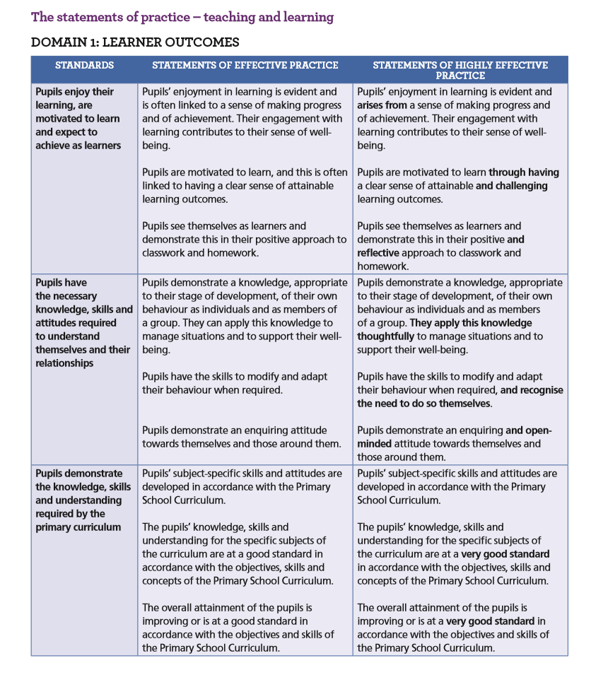

Found at:
http://schoolself-evaluation.ie/primary/wp-content/uploads/sites/2/2016/08/Looking-at-Our-School-2016-A-Quality-Framework-for-Primary-Schools_English_WEB.pdf

Step 4. Reporting

[School name] Our Self-Evaluation Report and Improvement Plan

1. Introduction

This document records the outcomes of our last improvement plan, the findings of this self-evaluation, and our current improvement plan, including targets and the actions we will implement to meet the targets.
  - Outcomes of our last improvement plan from [date] to [date]

1.2 The focus of this evaluation

We undertook self-evaluation of teaching and learning during the period (month/year) to (month/year). We evaluated the following aspect(s) of teaching and learning:

2. Findings
2.1 This is effective / very effective practice in our school
List the main strengths of the school in teaching and learning.

2.2. This is how we know
List the evidence sources. Refer to pupils’ dispositions, attainment, knowledge and skills.

2.3 This is what we are going to focus on to improve our practice further
Specify the aspects of teaching and learning the school has identified and prioritised for further improvement.

3. Our improvement plan
On the next page, we have recorded:
- The targets for improvement we have set
- The actions we will implement to achieve these
- Who is responsible for implementing, monitoring and reviewing our improvement plan
- How we will measure progress and check outcomes (criteria for success)
As we implement our improvement plan we will record:
- The progress made, and adjustments made, and when
Achievement of targets (original and modified), and when

Our Improvement Plan
Timeframe of this improvement plan is from [date] to [date]

Targets | Actions | Persons / groups responsible | Criteria for success | Progress and adjustments | Targets achieved

