Exercise 1: Principles of Junior Cycle
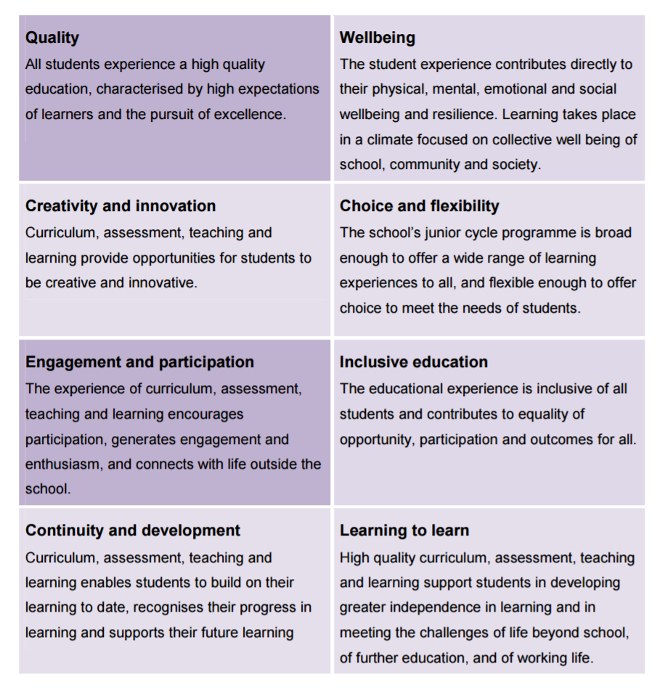
How do we implement the Principles in our school?
Quality | Wellbeing
Creativity and innovation | Choice and flexibility
Engagement and participation | Inclusive education
Continuity and development | Learning to learn

